Software Design
Specification

FreeCell Solitaire Java Project
Revision v. 2020.10.29

Table of Contents
Table of Contents ii
1. Introduction 1
1.1 Purpose 1
1.2 System Overview 1
1.3 Design Map 1
1.4 Definitions and Acronyms 1
2. Physical Analysis 1
2.1 Objects 1
2.1.1 Playing Card (see 3.1.1) 1
2.1.2 Deck (see 3.1.2) 2
2.1.3 Free Cell (see 3.1.3) 2
2.1.4 Foundation (see 3.1.4) 2
2.1.5 Card Column (see 3.1.5) 2
2.1.6 Tableau (see 3.1.6) 2
2.1.7 Hand (see 3.1.7) 3
2.1.8 Table (see 3.1.8) 3
2.1.9 Player (see 3.1.9) 3
2.2 Actions 3
2.3 Rules of Play 3
2.3.1 Legal sources for cards 3
2.3.2 Legal destinations for cards 4
2.3.3 Ending the Game 4
3. Objects 5
3.1 Classes Used 5
3.1.1 Card (see 2.1.1) 5
3.1.2 Deck (see 2.1.2) 5
3.1.3 FreeCell (see 2.1.3) 5
3.1.4 Foundation (see 2.1.4) 5
3.1.5 CardColumn (see 2.1.5) 5
3.1.6 Tableau (see 2.1.6) 5
3.1.7 Hand (see 2.1.7) 6
3.1.8 Table (see 2.1.8) 6
3.1.9 Player (see 2.1.9) 6
3.2 Class Diagram 6
3.3 Object Relationship Diagram 6
4. Design Considerations 6
4.1 Constraints 6
4.2 System Environment 6
4.3 Design Methodology 7
4.4 Risks and Volatile Areas 7
5. Architecture 7
5.1 Overview 7
5.2 Subsystem, Component, or Module 1 …N 7
5.3 Strategy 1…N 7
Appendix A: Project Timeline 8

Introduction

Purpose
This design will detail the implementation of the requirements as defined in the Software Requirements Specification – Binder Workflow – Phase 2.

System Overview
This project recreates a Java implementation of the game, FreeCell Solitaire. This includes the use of a graphical user interface, the cards for the game, and the

Design Map
SUE - Summarize the information contained within this document or the family of design artifacts. Define all major design artifacts and/or major sections of this document and if appropriate, provide a brief summary of each. Discuss any significant relationships between design artifacts and other project artifacts.

Definitions and Acronyms
Free cell(s) – 4 positions that can store a single card temporarily at the top left of the screen
Foundation(s) – 4 Positions that allow the build of the particular suit from Ace to King (Aces are Low)
Tableau – Holds 8 lines of cards that are dealt at the beginning of the game and the main play area

Physical Analysis

Objects

Playing Card (see 3.1.1)
  - Key component of solitaire and most card games
  - There are fifty-two unique types of playing cards, excluding the red and black jokers
  - Each card has a suit
    - Red Suits:
      - Hearts
      - Diamonds
    - Black Suits:
      - Clubs
      - Spades
  - Each card has a rank (this is in ascending order)
    - Ace
    - Two
    - Three
    - Four
    - Five
    - Six
    - Seven
    - Eight
    - Nine
    - Ten
    - Jack
    - Queen
    - King
  - Each card also has a value, but its value is decided by that specific game (not relevant here)
  - The combination of thirteen ranks and four suits leads to the fifty-two unique cards
  - The card has a face side that shows the rank and suit and another face-down side that hides it TODO
    - Face-Up – Rank and suit are visible
    - Face-Down – Rank and suit are not visible

Deck (see 3.1.2)
  - A pile of a maximum of fifty-two unique playing cards
  - No jokers
  - Cards are face-down
  - The top card is visible

Free Cell (see 3.1.3)
- Temporary storage
- Has either zero or one card
- Cards are stored face up
- The top card is visible

Foundation (see 3.1.4)
- Holds an ascending order of cards from Ace to King
- Has a specific suit of cards it will accept
- Cards are face-up
- The top card is visible
- Maximum of thirteen cards can be stored

Card Column (see 3.1.5)
  - Cards are face-up
  - All cards are visible
  - Maximum of nineteen cards can be stored

Tableau (see 3.1.6)
  - Stores eight card columns

Hand (see 3.1.7)
  - Holds zero or one cards
  - Cards are face up
  - The card is visible

Table (see 3.1.8)
- Storage area for game components
  - Four free cells
  - Four foundations
  - A tableau
  - A deck

Player (see 3.1.9)
  - The person or people playing the game
  - The player performs actions on the different aspects of the game

Actions
- Shuffles the deck
- Deals the cards
  - One in each column
  - Face-up
  - Fill the first row by left to right
  - Do the same five more times for rows two to six
  - For the seventh row fill the first four columns with the remaining cards
    - No cards should remain
- Choose a card from a source
  - Consult the rules for legality
- Choose a destination if the source was legal
  - Consult the rules for legality
- Move the card from the source location to the destination if the destination was a legal move from the source
- Determine if we have won the game

Rules of Play

Legal sources for cards

List of legal sources

- Top of a column of cards
- Free Cell
- Top of the foundation

When are they legal sources?
- When the hand has no card in it
- When they have a moveable card that has a legal destination

Legal destinations for cards

Column of cards

- The card to be moved must one less than the card on the top of the column
  - The top of the column refers to the highest stacked card
  - Usually displayed at the bottom of the column visually
- The card must be of a suit for the opposite color
  - If the top card of the column is a red suit, the card to move must be a black suit
  - If the top card of the column is a black suit, the card to move must be a red suit
- If the column of cards is empty, any card can be placed there
- The column of cards may not follow the rules that would apply as if was a destination for the initial setup of cards

Free Cell
- The free cell must contain no cards

Foundation
- The card must be of the same suit as the foundation’s set suit
- The card must be an ace
- The card must be one higher than the card that is currently at the top of the foundation

Ending the Game

Winning
- The game is won when all four foundations each contain the thirteen cards of their assigned suit
- No cards are in the free cells
- No cards are in the hand
- No cards are in the columns of cards

Losing
- Happens when there are no remaining moves with legal destinations

Quitting the Game
- Caused when the player chooses to stop playing

Objects

Interfaces Used
- DeckADT – Interface ADT
  - You can create a new empty deck
  - You can add a card to the bottom of the deck
  - You can draw a card from the top of the deck
  - You can look at how many cards are left in the deck
  - You can shuffle the deck
- CardCollection – Interface ADT
  - You can create an empty collection of cards
  - You can add a card to the collection
  - You can remove and retrieve the last added card from the collection
  - You can retrieve at the last added card in the collection
  - You can check if a card can go into that collection

Enumerations

Rank
- ACE
- TWO
- THREE
- FOUR
- FIVE
- SIX
- SEVEN
- EIGHT
- NINE
- TEN
- JACK
- QUEEN
- KING

Suit
- HEARTS
- DIAMONDS
- CLUBS
- SPADES

Extra Notice
- The enumerations have a method to return a string of their selected option in Title Case, an example of this is that DIAMONDS will become Diamonds

Classes Used

Card (see 2.1.1)

Attributes
- suit: Suit
- rank: Rank
- value: int
- isVisible: bool

Actions

Public Methods
- Card(Suit suit, Rank, rank, int value)
- setIsVisible(bool isVisible): void
- setValue(int value): void
- getIsVisible(): bool
- getSuit(): Suit
- getRank(): Rank
- getImage(): String

GraphicalCard (see 2.1.1)

Attributes
- cardImage: CardImage
- suit: Suit
- rank: Rank
- value: int
- isVisible: bool

Actions

Public Methods
- GraphicalCard(String frontImage, Suit suit, Rank, rank, int value)
- setIsVisible(bool isVisible): void
- setValue(int value): void
- getIsVisible(): bool
- getSuit(): Suit
- getRank(): Rank
- getImage(): String

CardImage (Private Inner Class in Card)

Attributes
- frontImage: String
- backImage: String

Actions

Public Methods
- CardImage(String frontImage)
- getImage(bool isVisible): String

GraphicalDeck (see 2.1.2)

Attributes
- cards: Card[]
- last: int

Actions

Public Methods
- Deck()
- add(Card card): void
- drawTop(): Card
- getSize(): int
- shuffle(): void
- retrieveAces(int number): Card[]

Private Methods

- fill(): void

FreeCell (see 2.1.3)

Attributes
- card: Card

Actions

Public Methods
- FreeCell()
- addCard(Card card): void
- getCard(): Card
- removeCard(): Card
- checkLegal(Card card): bool

Foundation (see 2.1.4)

Attributes
- assignedSuit: Suit
- cards: Stack<Card>

Actions

Public Methods
- Foundation(Suit assignedSuit)
- addCard(Card card): void
- getCard(): Card
- removeCard(): Card
- checkLegal(Card card): bool
- checkSize(): int

CardColumn (see 2.1.5)

Attributes
- Cards: Stack<Card>

Actions

Public Methods
- CardColumn()
- addCard(Card card): void
- getCard(): Card
- removeCard(): Card
- checkLegal(Card card): bool
- checkSize(): int
- getCardImages(): String[]

Tableau (see 2.1.6)

Attributes
- cardColumns: CardColumn[]

Actions

Public Methods
- Tableau()
- getCardColumn(int index): CardColumn

Table (see 2.1.8)

Attributes
- tableau: Tableau
- foundations: Foundation[]
- freeCells: FreeCell[]

Actions

Public Methods
- Table()
- getTableau(): Tableau
- getFoundation(int index): Foundation
- getFreeCell(int index): FreeCell

Program

Attributes

Actions

Public Methods
- main(String[] args): void

Controller

Attributes
- controller: Controller
- display: DisplayGUI
- table: Table
- lastTime: long
- move: int
- playing: bool
- pointerToSelected: CardCollection
- deck: Deck

Actions

Public Methods
- getInstance(): Controller
- runGameLoop(): void
- selectCard(int indentifier): void
- main(String[] args): void

Private Methods
- executionCycle(): void
- updateDisplay(): void
- updateDisplayStatistics(): void
- endGame(): void
- checkForEndOfGame(): void

ConfigurationHandler

Attributes
- Config: HashMap<String, Integer>
- FILE_NAME: String

Actions

Public Methods
- getConfig(): HashMap<String, Integer>
- readConfig(): bool
- writeConfig(HashMap<String, Integer>): bool
- alterConfig(HashMap<String, Integer>): bool

Private Methods
- findFilePath(): String

DisplayGUI

Attributes
- execute: GUIActions
- controller: Controller
- extraInformation: String
- frame: JFrame
- menuBar: JMenuBar
- gameMenu: JMenu
- helpMenu: JMenu
- quitGameMenuItem: JMenuItem
- forceQuitGameMenuItem: JMenuItem
- howToPlayMenuItem: JMenuItem
- programInfoMenuItem: JMenuItem
- cardColumnPanel1: JPanel
- cardColumnPanel2: JPanel
- cardColumnPanel3: JPanel
- cardColumnPanel4: JPanel
- cardColumnPanel5: JPanel
- cardColumnPanel6: JPanel
- cardColumnPanel7: JPanel
- cardColumnPanel8: JPanel
- freeCellPanel1: JPanel
- freeCellPanel2: JPanel
- freeCellPanel3: JPanel
- freeCellPanel4: JPanel
- foundationPanel1: JPanel
- foundationPanel2: JPanel
- foundationPanel3: JPanel
- foundationPanel4: JPanel

Actions

Public Methods
- DisplayGUI(Controller controller)
- makeFrame(): void
- makeMenuBar(): void
- updateTable(String[][] cardColumnImages, String[] freeCellImages, String[] foundationImages): void
- updateExtraInformation(long timePlayed, int turnsPlayed, String extraInfo): void
- moveFailed(String message): void
- moveSuccess(): void
- gameWon(): void
- gameLost(): void
- gameEnded(): void

Private Methods
- showHowToPlayDialog(): void
- showProgramInfo(): void
- quitGame(): void
- forceQuitGame(): void

UserInput (Private Inner Class in DisplayGUI)

Attributes

Actions

Public Methods
- UserInput()

Private Methods
- selectFoundation(int index): void
- selectFreeCell(int index): void
- selectCardColumn(int index): void

Class Diagram
https://lucid.app/invitations/accept/d5bbe810-6624-4769-a7c9-d1175520a114

Object Relationship Diagram
https://lucid.app/invitations/accept/921e04f7-927f-4d4c-a840-c9d20c92662c

Design Considerations

Constraints
None that I am aware of.

System Environment
The Solitaire game is built on Java and needs to run on at least the big three types of desktop operating systems (Windows, MacOS, Linux).

Design Methodology
- The necessary classes with their members among other things will be considered and written down
- ADTs will be created on paper
- Axioms will be plotted out
- Class Diagrams will be created
- Classes, fields, and method headers will be added
- JavaDoc will be created
- Unit tests will be written
- Methods are implemented

UI Design

Initial Design

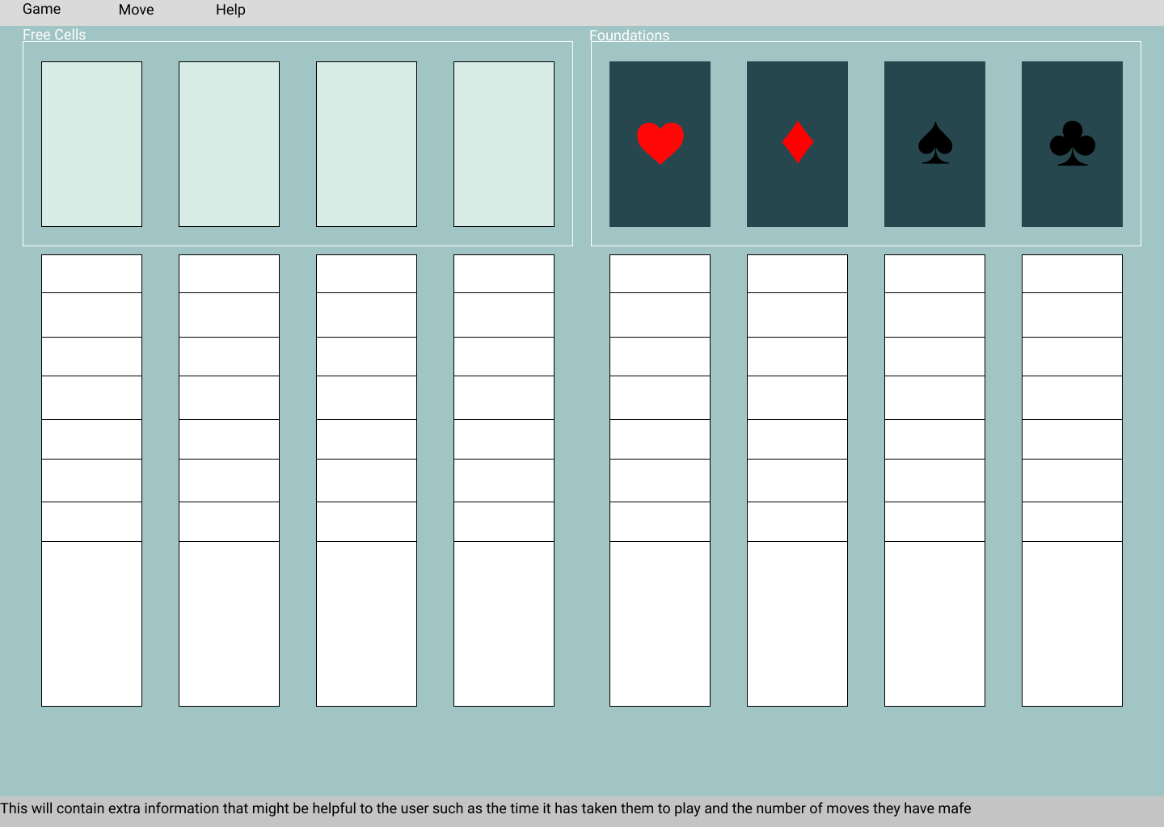

Extra Information
This design is the initial idea for the implemented user interface. It includes a menu bar with the options: Game, Move, and Help. Game is used to quit the game early and either return to the main menu or quit the program. Move is used to add another way of moving the card on the board from one legal space to another at the cost of being slower. It also shows the hotkeys to bring up that menu. Help allows the user to see program info and how to play the game.
The free cells are differentiated from the foundations by their background color and the lack of an indicated suit. They are also separated by a named border saying that they are they free cells. Foundations show the suit that will be accepted by that position. The cards for the card columns are underneath and are planned to be aligned to the cards up above. The outlines for the cards and card slots are only here for display purposes and the white card spots represent cards if they were in those positions. The foundation and free cell backgrounds will be hidden when a card is placed on them.
At the bottom is the status bar. What will be here is currently unknown. It will likely keep track of the time spent to play the game and the number of moves that have been taken. It is there for any other helpful information the player may want to see. It may also show the number of available moves the player may choose to take.

Appendix A: Project Timeline
N/A

